

MOVIE BOOKING

COMPUTER SCIENCE – PROJECT REPORT FILE



January 10, 2020

jash veragiwala, nishant modak

Class 11-A

|  |  |  |
| --- | --- | --- |
| Table of contents | | |
| No | Content | Page No |
| 1 | Introduction | 2 |
| 2 | Detailed Description | 2-8 |
| 3 | Technical Description | 2-8 |
| 4 | Python Code | 8-17 |
| 5 | Screen shots | 17-21 |

**Introduction**

This is a Movie ticket booking program. You can select from 5 different movies, each with three different showtimes on three different dates. The program can display a 10x10 seat map where you can enter the coordinates of the seats you want to book. You have the option to change your seats after selecting them if you wish. You also have the option to purchase food and beverage from a variety of combos and a la carte items. After selecting your food and beverage items, you can once again add or delete items if you wish. After that, your items will be booked, and you will be shown the seats that you have booked on the seat map and the food and beverage items that you have booked.

**Detailed/Technical Description**

**1.Storage of seats:**

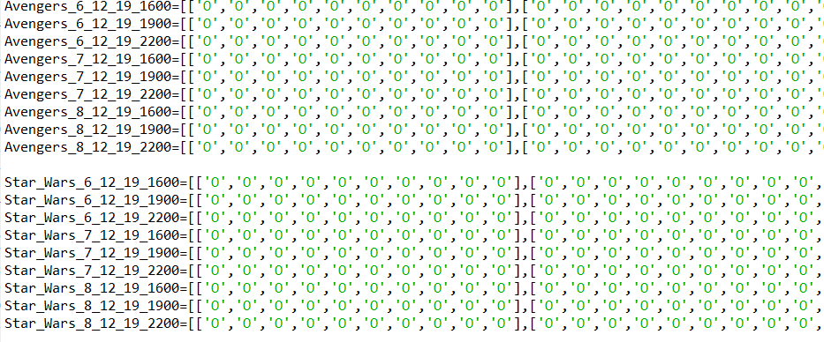

The seats are stored in the form of indented lists. Each indented list represents the status of the 10 seats of that row. ‘O’ meaning empty and ‘X’ meaning occupied. There are 10 such indented lists within the main list, one for each row (A,B,C…). Apart from the indented lists, the main list also contains the date and time of the movie as the last two elements. This helps us easily identify the correct list to use. There are 45 such lists (5 movies x 3 days x 3 showtimes).

**2. Seat printing:**

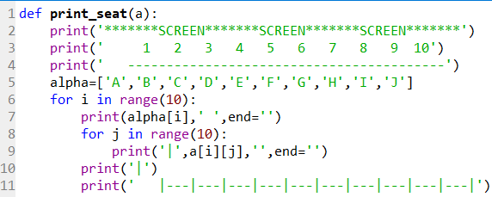

Here, a function is defined which takes the main movie list as the input and outputs the seat map. The 2,3,4 lines print the standard lines of the seat map. Line 7 prints the row letter (eg-A, B, C) by using alpha[i], where i=0 to 9. Line 9 helps us print each individual ‘O’ or ‘X’ that is stored inside the indented list. The output is as shown:

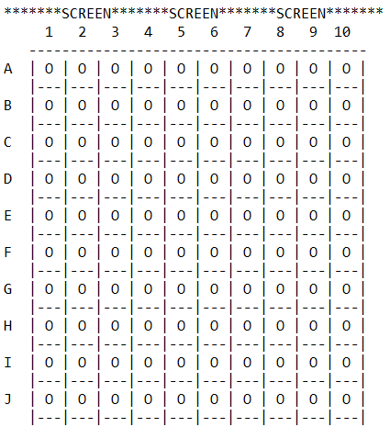

This helps the user visualize where their seat will be so that they can select it accordingly.

**3. Movie and seat selection menu:**

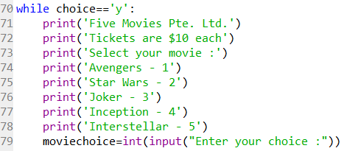

This is a basic menu where there are 5 movies to chose from. The user is asked to input their choice. This entire program is indented in a while loop (line 70) so that the user can continue the program once the seats are booked.

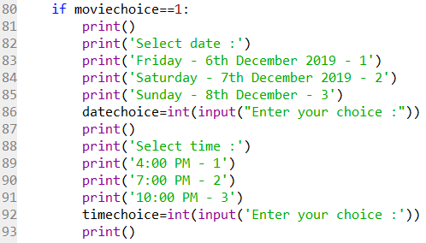

This section of the code is repeated 5 times (once for each movie). Here, the user inputs their preferred date and time that is stored as the variables ‘datechoice’ and ‘timechoice’ respectively.

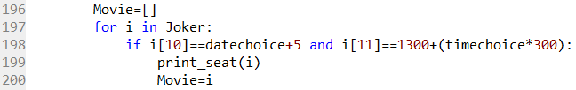

This section of the code is used to identify which Movie list is to be used. In line 198, i[10] will give us the 11th element of the Movie’s list which contains the date of the move. Datechoice+5 is used to convert the users input i.e. 1,2,3 to the movie’s dates i.e. 6,7,8. i[11] is the 12th element of the list and contains the time of the movie. 1300+(timechoice*300) is used to convert the user input 1,2,3 to the 24-hour notation i.e. 1600,1900,2100 since that is how the time is stored in the list. Line 199 is used to print the seat map of the selected movie. Line 200 helps us stored the selected movie list as ‘Movie’.

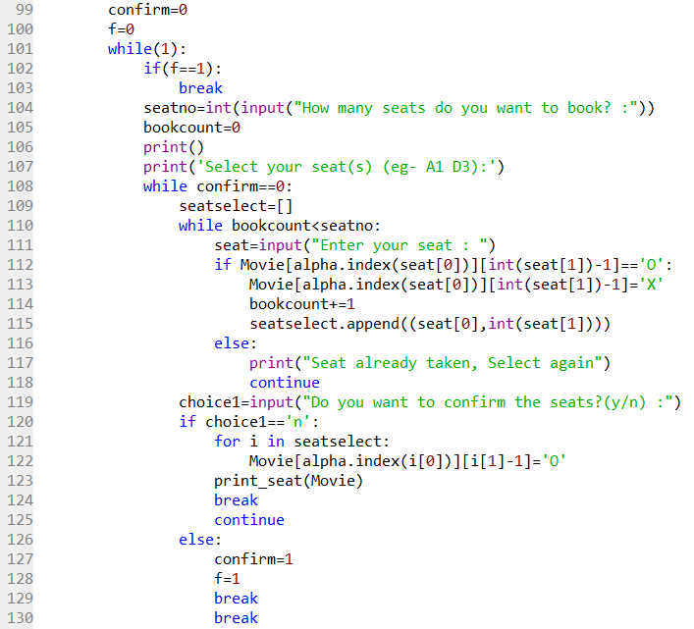

Here, the multiple while loops are used so that the user can change their seats and so that if the user inputs a seat which is already taken, they will be asked to select an empty seat until they do so.

In line 104, the user is asked to input the number of seats they want to book. This is useful as it tells us how many times the loop has to repeat itself.

In line 111, the user is asked to input the seat coordinate. Line 112 is used to check whether the seat inputted is occupied or not. In [int(seat[1])-1], int(seat[1]) gives us the column name eg- 1,5,8. Since index values are stored starting form 0, the -1 is used. In [alpha.index(seat[0])], seat [0] gives us the row letter and the alpha.index gives us the corresponding numeral value of the row letter, eg- a=0, b=1 etc. Together, Movie[alpha.index(seat[0])][int(seat[1])-1] will give us the element in the Movie lists which corresponds to the seat entered. For example, if the seat entered isB2,Movie[alpha.index(seat[0])][int(seat[1])-1] becomes Movie[alpha.index(B)][int(2)-1] --- Movie[1][1] which will give the second element of the second indented list in the Movie list, which is the element that corresponds to seat B2 in the seat map. Line 113 is used to change the status of the seat from empty ‘O’ to occupied ‘X’. Line 114 adds 1 to Seatselect which helps us keep track of how many seats have been selected. Line 115 is used to add the selected seats into another list so that if the user wants to change seats, we can delete the previously selected seats.

In line 119, the user is asked if they want to confirm the seats or re-select them. If the user wishes to reselect the seats, lines 121 and 122 change the previously selected from occupied ‘X’ back to empty ‘O’. The break command brings the program back to line 104 where the user can select their seats again. But if the user wants to confirm seats, the two break statements and f=1 will make the program exit all the loops and move on to the next section.

**4. Food and Beverage selection menu**

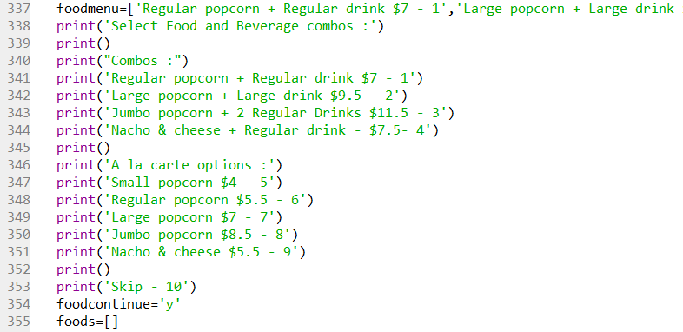

Foodmenu stores all the menu items. The print statements are used to create a menu.

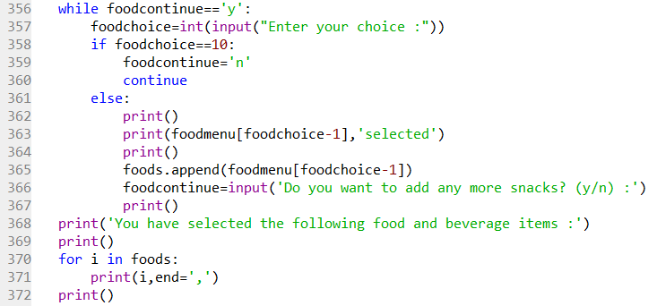

Line 357 asks for the users input. Line 363 will print the selected food item and line 365 will add it to the list ‘foods’ which contains the selected food and beverage items then it asks the user if they want to add anymore snacks. Line 370 and 371 is used to print the entire order

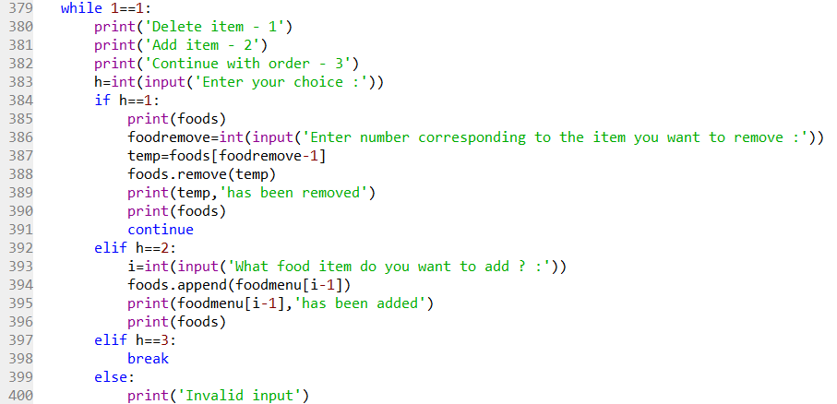

This section is used to add or delete an item. List.remove and list.append function is used to delete or add item(s).

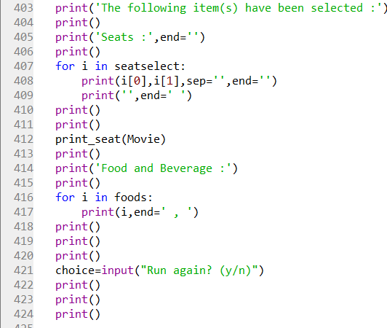

This section will print the seats selected along with the seat map and also, the food and beverage options selected.

**Python Code:**

def print_seat(a):

print('*******SCREEN*******SCREEN*******SCREEN*******')

print(' 1 2 3 4 5 6 7 8 9 10')

print(' -----------------------------------------')

alpha=['A','B','C','D','E','F','G','H','I','J']

for i in range(10):

print(alpha[i],' ',end='')

for j in range(10):

print('|',a[i][j],'',end='')

print('|')

print(' |---|---|---|---|---|---|---|---|---|---|')

alpha=['A','B','C','D','E','F','G','H','I','J']

Avengers_6_12_19_1600=[['O','O','O','O','O','O','O','O','O','O'],……., 6,1600]

#Movie lists will be skipped since they are repeated

choice='y'

while choice=='y':

print('Five Movies Pte. Ltd.')

print('Tickets are $10 each')

print('Select your movie :')

print('Avengers - 1')

print('Star Wars - 2')

print('Joker - 3')

print('Inception - 4')

print('Interstellar - 5')

moviechoice=int(input("Enter your choice :"))

if moviechoice==1:

print()

print('Select date :')

print('Friday - 6th December 2019 - 1')

print('Saturday - 7th December 2019 - 2')

print('Sunday - 8th December - 3')

datechoice=int(input("Enter your choice :"))

print()

print('Select time :')

print('4:00 PM - 1')

print('7:00 PM - 2')

print('10:00 PM - 3')

timechoice=int(input('Enter your choice :'))

print()

Movie=[]

for i in Avengers:

if i[10]==datechoice+5 and i[11]==1300+(timechoice*300):

print_seat(i)

Movie=i

confirm=0

f=0

while(1):

if(f==1):

break

seatno=int(input("How many seats do you want to book? :"))

bookcount=0

print()

print('Select your seat(s) (eg- A1 D3):')

while confirm==0:

seatselect=[]

while bookcount<seatno:

seat=input("Enter your seat : ")

if Movie[alpha.index(seat[0])][int(seat[1])-1]=='O':

Movie[alpha.index(seat[0])][int(seat[1])-1]='X'

bookcount+=1

seatselect.append((seat[0],int(seat[1])))

else:

print("Seat already taken, Select again")

continue

choice1=input("Do you want to confirm the seats?(y/n) :")

if choice1=='n':

for i in seatselect:

Movie[alpha.index(i[0])][i[1]-1]='O'

print_seat(Movie)

break

continue

else:

confirm=1

f=1

break

break

elif moviechoice==2:

print()

print('Select date :')

print('Friday - 6th December 2019 - 1')

print('Saturday - 7th December 2019 - 2')

print('Sunday - 8th December - 3')

datechoice=int(input("Enter your choice :"))

print()

print('Select time :')

print('4:00 PM - 1')

print('7:00 PM - 2')

print('10:00 PM - 3')

timechoice=int(input('Enter your choice :'))

print()

Movie=[]

for i in Star_Wars:

if i[10]==datechoice+5 and i[11]==1300+(timechoice*300):

print_seat(i)

Movie=i

confirm=0

f=0

while(1):

if(f==1):

break

seatno=int(input("How many seats do you want to book? :"))

bookcount=0

print()

print('Select your seat(s) (eg- A1 D3):')

while confirm==0:

seatselect=[]

while bookcount<seatno:

seat=input("Enter your seat : ")

if Movie[alpha.index(seat[0])][int(seat[1])-1]=='O':

Movie[alpha.index(seat[0])][int(seat[1])-1]='X'

bookcount+=1

seatselect.append((seat[0],int(seat[1])))

else:

print("Seat already taken, Select again")

continue

choice1=input("Do you want to confirm the seats?(y/n) :")

if choice1=='n':

for i in seatselect:

Movie[alpha.index(i[0])][i[1]-1]='O'

print_seat(Movie)

break

continue

else:

confirm=1

f=1

break

break

if moviechoice==3:

print()

print('Select date :')

print('Friday - 6th December 2019 - 1')

print('Saturday - 7th December 2019 - 2')

print('Sunday - 8th December - 3')

datechoice=int(input("Enter your choice :"))

print()

print('Select time :')

print('4:00 PM - 1')

print('7:00 PM - 2')

print('10:00 PM - 3')

timechoice=int(input('Enter your choice :'))

print()

Movie=[]

for i in Joker:

if i[10]==datechoice+5 and i[11]==1300+(timechoice*300):

print_seat(i)

Movie=i

confirm=0

f=0

while(1):

if(f==1):

break

seatno=int(input("How many seats do you want to book? :"))

bookcount=0

print()

print('Select your seat(s) (eg- A1 D3):')

while confirm==0:

seatselect=[]

while bookcount<seatno:

seat=input("Enter your seat : ")

if Movie[alpha.index(seat[0])][int(seat[1])-1]=='O':

Movie[alpha.index(seat[0])][int(seat[1])-1]='X'

bookcount+=1

seatselect.append((seat[0],int(seat[1])))

else:

print("Seat already taken, Select again")

continue

choice1=input("Do you want to confirm the seats?(y/n) :")

if choice1=='n':

for i in seatselect:

Movie[alpha.index(i[0])][i[1]-1]='O'

print_seat(Movie)

break

continue

else:

confirm=1

f=1

break

break

if moviechoice==4:

print()

print('Select date :')

print('Friday - 6th December 2019 - 1')

print('Saturday - 7th December 2019 - 2')

print('Sunday - 8th December - 3')

datechoice=int(input("Enter your choice :"))

print()

print('Select time :')

print('4:00 PM - 1')

print('7:00 PM - 2')

print('10:00 PM - 3')

timechoice=int(input('Enter your choice :'))

print()

Movie=[]

for i in Inception:

if i[10]==datechoice+5 and i[11]==1300+(timechoice*300):

print_seat(i)

Movie=i

confirm=0

f=0

while(1):

if(f==1):

break

seatno=int(input("How many seats do you want to book? :"))

bookcount=0

print()

print('Select your seat(s) (eg- A1 D3):')

while confirm==0:

seatselect=[]

while bookcount<seatno:

seat=input("Enter your seat : ")

if Movie[alpha.index(seat[0])][int(seat[1])-1]=='O':

Movie[alpha.index(seat[0])][int(seat[1])-1]='X'

bookcount+=1

seatselect.append((seat[0],int(seat[1])))

else:

print("Seat already taken, Select again")

continue

choice1=input("Do you want to confirm the seats?(y/n) :")

if choice1=='n':

for i in seatselect:

Movie[alpha.index(i[0])][i[1]-1]='O'

print_seat(Movie)

break

continue

else:

confirm=1

f=1

break

break

if moviechoice==5:

print()

print('Select date :')

print('Friday - 6th December 2019 - 1')

print('Saturday - 7th December 2019 - 2')

print('Sunday - 8th December - 3')

datechoice=int(input("Enter your choice :"))

print()

print('Select time :')

print('4:00 PM - 1')

print('7:00 PM - 2')

print('10:00 PM - 3')

timechoice=int(input('Enter your choice :'))

print()

Movie=[]

for i in Interstellar:

if i[10]==datechoice+5 and i[11]==1300+(timechoice*300):

print_seat(i)

Movie=i

confirm=0

f=0

while(1):

if(f==1):

break

seatno=int(input("How many seats do you want to book? :"))

bookcount=0

print()

print('Select your seat(s) (eg- A1 D3):')

while confirm==0:

seatselect=[]

while bookcount<seatno:

seat=input("Enter your seat : ")

if Movie[alpha.index(seat[0])][int(seat[1])-1]=='O':

Movie[alpha.index(seat[0])][int(seat[1])-1]='X'

bookcount+=1

seatselect.append((seat[0],int(seat[1])))

else:

print("Seat already taken, Select again")

continue

choice1=input("Do you want to confirm the seats?(y/n) :")

if choice1=='n':

for i in seatselect:

Movie[alpha.index(i[0])][i[1]-1]='O'

print_seat(Movie)

break

continue

else:

confirm=1

f=1

break

break

totalcost=len(seatselect)*10

print()

foodmenu=['Regular popcorn + Regular drink $7 - 1','Large popcorn + Large drink $9.5 - 2','Jumbo popcorn + 2 Regular Drinks $11.5 - 3','Nacho & cheese + Regular drink $7.5 - 4','Small popcorn $4 - 5','Regular popcorn $5.5 - 6','Large popcorn $7 - 7','Jumbo popcorn $8.5 - 8','Nacho & cheese $5.5 - 9']

print('Select Food and Beverage combos :')

print()

print("Combos :")

print('Regular popcorn + Regular drink $7 - 1')

print('Large popcorn + Large drink $9.5 - 2')

print('Jumbo popcorn + 2 Regular Drinks $11.5 - 3')

print('Nacho & cheese + Regular drink - $7.5- 4')

print()

print('A la carte options :')

print('Small popcorn $4 - 5')

print('Regular popcorn $5.5 - 6')

print('Large popcorn $7 - 7')

print('Jumbo popcorn $8.5 - 8')

print('Nacho & cheese $5.5 - 9')

print()

print('Skip - 10')

foodcontinue='y'

foods=[]

while foodcontinue=='y':

foodchoice=int(input("Enter your choice :"))

if foodchoice==10:

foodcontinue='n'

continue

else:

print()

print(foodmenu[foodchoice-1],'selected')

print()

foods.append(foodmenu[foodchoice-1])

foodcontinue=input('Do you want to add any more snacks? (y/n) :')

print()

print('You have selected the following food and beverage items :')

print()

for i in foods:

print(i,end=',')

print()

h=0

print()

print()

print()

print('Edit your order :')

print()

while 1==1:

print('Delete item - 1')

print('Add item - 2')

print('Continue with order - 3')

h=int(input('Enter your choice :'))

if h==1:

print(foods)

foodremove=int(input('Enter number corresponding to the item you want to remove :'))

temp=foods[foodremove-1]

foods.remove(temp)

print(temp,'has been removed')

print(foods)

continue

elif h==2:

i=int(input('What food item do you want to add ? :'))

foods.append(foodmenu[i-1])

print(foodmenu[i-1],'has been added')

print(foods)

elif h==3:

break

else:

print('Invalid input')

print()

print('The following item(s) have been selected :')

print()

print('Seats :',end='')

print()

for i in seatselect:

print(i[0],i[1],sep='',end='')

print('',end=' ')

print()

print()

print_seat(Movie)

print()

print('Food and Beverage :')

print()

for i in foods:

print(i,end=' , ')

print()

print()

print()

choice=input("Run again? (y/n)")

print()

print()

print()

**Output:**

